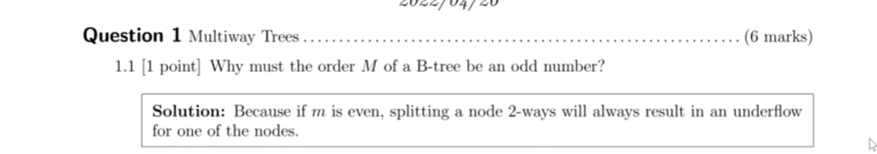

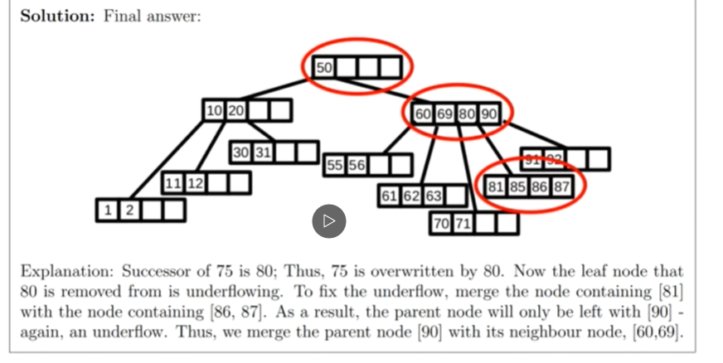

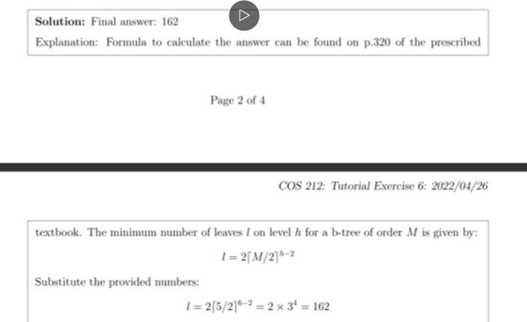

TUT 7

TUT 8

TUT 9

